Lab Task 06
Zain jabbar (323)
AI (lab)
Q:1
Create task1_tokens.py. • Compare whitespace splitting and Unicode word-like regex tokens for at least six inputs: punctuation, a contraction, an email, CS4944, an empty string and Urdu text. • Print original text, token lists and counts. • Add the model tokenizer for two English examples if available. • Explain two differences and one normalization risk; do not claim the regex is a complete multilingual tokenizer. Run guided_chatbot.py with TF-IDF. • Add two FAQs, each with a source. • Capture one exact answer, one suggestion response and one empty or unsupported input. • Explain why the chatbot asks for confirmation on nonexact questions.
What I did
- The program has two parts: tokenization and a small FAQ chatbot.
- Tokenization uses a regex to split six sample texts (punctuation, contraction, email, URL, emoji, Urdu) into words and symbols, then prints the tokens and their count.
- If tiktoken is installed, it also prints model token counts; otherwise it skips this step without crashing.
- The chatbot stores three FAQ questions with answers and scores word overlap using IDF, so rare words matter more than common ones.
- An exact question match gives the answer directly, a similar question gets a “Did you mean...?” suggestion, and empty input gets “Please enter a question.”
- With --interactive, you can type your own questions, and the bot asks for a y/n confirmation before giving the answer to a suggested question.
Code screenshot

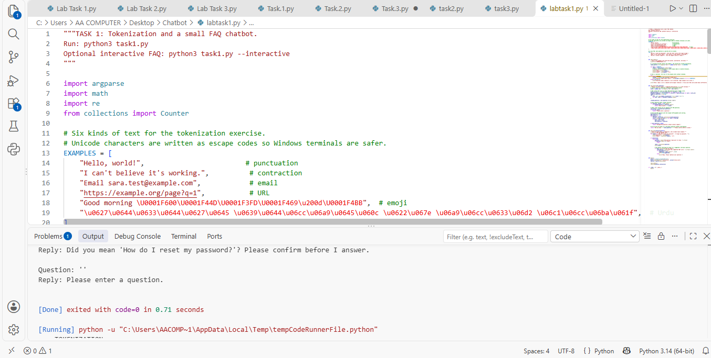

Code Explanation

1. Imports
argparse reads command-line options like --interactive. math is used for the logarithm in the IDF formula. re is used for regular expressions (pattern matching). Counter counts how many times items appear.

2. EXAMPLES list
It has six sample texts to tokenize: punctuation, a contraction, an email, a URL, emoji, and Urdu. Unicode characters are written as escape codes so they do not break on Windows terminals.

3. FAQ dictionary
It stores three FAQ questions, each paired with its answer. The chatbot searches in this dictionary.

4. show_tokens() - Tokenization
A regex pattern splits each text into tokens. The first part matches a word and keeps contractions together (can't stays as one token). The second part matches any single punctuation or symbol character. The code prints the text, its tokens, and the token count. The ascii() function prints Urdu and emoji as safe escape codes.
If the tiktoken library is installed, the code also prints the token counts of a real AI model tokenizer. If it is not installed, a message is printed and the program continues without error.
At the end, a note explains that regex is not a complete multilingual tokenizer because it may split URLs and joined emoji differently from a model tokenizer.

5. faq_answer() - Chatbot logic
Step 1: The words function converts text to lowercase and extracts words, so Password and password match.
Step 2: IDF (Inverse Document Frequency) is calculated for every word in the FAQ questions. A word that appears in fewer questions gets a higher score, so rare words matter more than common words like how or do.
Step 3: If the user's question exactly matches a FAQ question, the answer is returned directly.
Step 4: If the input is empty, it returns "Please enter a question."
Step 5: Otherwise, for each FAQ question the code finds the words shared with the user's input and adds their IDF scores. The question with the highest score is the best match.
Step 6: If no words match, it returns "Unsupported question; please contact support."
Step 7: If there is a match, the bot does not answer directly. It asks "Did you mean ...? Please confirm before I answer." This avoids giving a wrong answer.

6. show_faq()
It runs three demo inputs: an exact question, a similar question ("I forgot my password"), and an empty string. If interactive mode is on, it keeps asking for questions until the user types quit. When the bot suggests a question, it asks for y/n. If the user types y, the answer is printed. Otherwise, it asks the user to rephrase.

7. main() and the last lines
main() creates the argparse option --interactive, then calls show_tokens() and show_faq(). The line if __name__ == "__main__" makes sure main() runs only when the file is run directly.
Code Run Screenshot
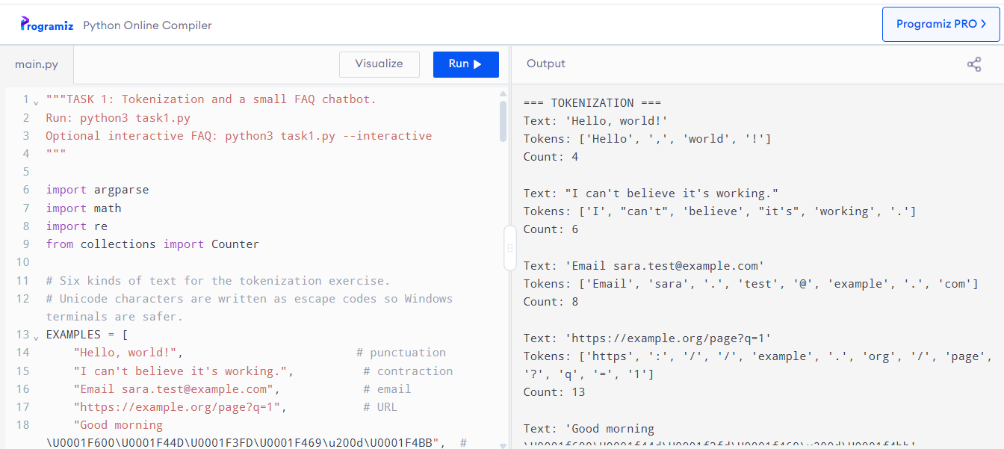
Q:2
Create task2_chunks.py. • Use at least three synthetic documents of 150–250 words each, including a rule with an exception and a long sentence. • Implement 40-word windows with overlaps 0 and 10, plus sentence-aware packing with a 40-word budget. • Store source offsets and IDs. Compare counts, sizes, repeated text and whether each labeled rule/exception survives in one chunk. • Test empty text, a document shorter than the budget, invalid overlap and a sentence longer than the budget. • Explain where sentence splitting fails, such as abbreviations. Run guided_embeddings.py and guided_suggestions.py with the embedding backend. • Build records from your chunks and compare three paraphrased queries with TF-IDF. • Display chunk IDs and original evidence. • Do not replace semantic embeddings with hand-invented vectors.
What I did
1. The program creates three synthetic documents (library, password, and travel policy), each with a rule and an exception.
2. Each document is padded with a repeated sentence until it has at least 150 words.
3. The word_windows function splits a text into chunks of 40 words, moving forward 10 words each time, so neighbouring chunks overlap by 30 words.
4. The sentence_windows function keeps whole sentences together up to 40 words, and splits any sentence longer than 40 words into smaller pieces.
5. Every chunk gets an ID, its source document, its character start and end positions, and a short preview; the program also counts repeated chunks, which happen because of the padding.
6. Finally, it tests edge cases: empty text, a very short document, and a sentence of 55 words, and prints the word count of each chunk.
Code Screenshot
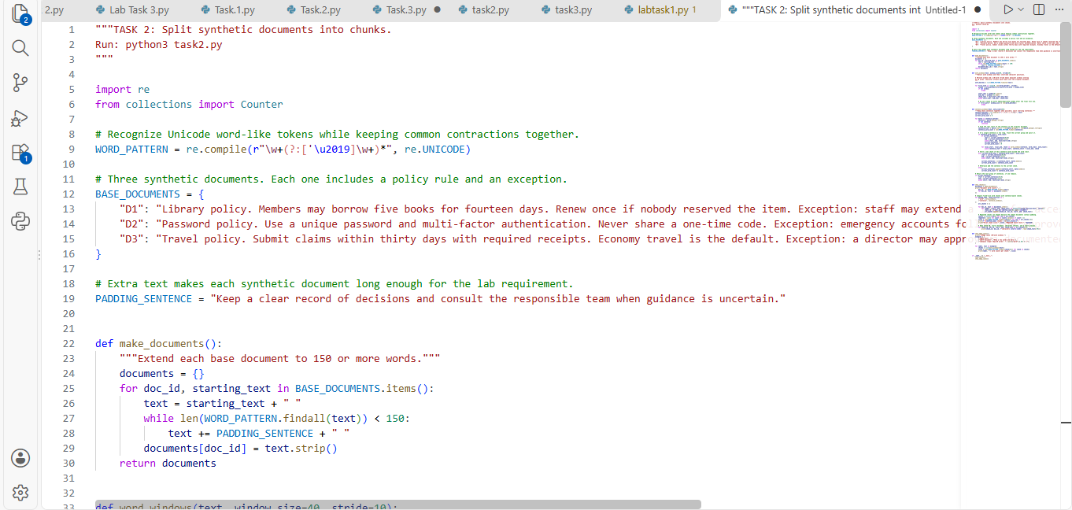

Code Explanation

1. Imports and WORD_PATTERN
re is used for regular expressions. Counter counts repeated items. WORD_PATTERN is a regex that finds word-like tokens and keeps contractions together (can't stays as one word). It works with Unicode, so non-English words are also found.

2. BASE_DOCUMENTS
Three short synthetic documents: library policy (D1), password policy (D2), and travel policy (D3). Each one has a normal rule and an exception.

3. PADDING_SENTENCE
One extra sentence that is added again and again to make each document long enough for the lab requirement.

4. make_documents()
For each base document, the code keeps adding PADDING_SENTENCE until the document has at least 150 words. The word count is checked using WORD_PATTERN. It returns a dictionary of the final documents.

5. word_windows(text, window_size=40, stride=10)
This is the fixed-size chunking method.
- It finds all words with finditer, so each word keeps its character position.
- A window takes 40 words. Then it moves forward by 10 words, so neighbouring chunks overlap by 30 words.
- For each window it takes the start position of the first word and the end position of the last word, then cuts that part from the original text.
- It yields (start_char, end_char, chunk_text).
- If the window already reaches the end of the document, the loop stops, so no extra duplicate window is created.

6. sentence_windows(text, word_limit=40)
This is the sentence-aware chunking method.
- It splits the text into sentences using a regex that ends at . ! or ?.
- It keeps adding whole sentences to the current chunk while the total stays within 40 words.
- If adding the next sentence would cross 40 words, the current chunk is yielded and a new chunk starts with that sentence.
- If one single sentence is longer than 40 words, the current chunk is yielded first, then that long sentence is split using word_windows with stride equal to window size (no overlap). The positions are shifted back so they point into the original document.
- At the end, any remaining sentences are yielded as the last chunk.

7. show_chunks()
- It creates the documents and prints the word count of each one.
- It runs both methods (word and sentence) on every document.
- Each chunk gets an ID like D1-W1 (word method) or D1-S1 (sentence method), plus its document, start and end character positions, and the text.
- It counts repeated chunk texts (these happen because of the padding sentence).
- It prints the number of chunks, the sizes of the first five chunks, and a 70-character preview of the first two chunks.

8. show_edge_cases()
It tests word_windows on three special inputs: empty text (no chunks), a short document (one small chunk), and a 55-word sentence (two chunks: 40 words and 15 words). It prints the word count of each chunk.

9. Last lines
if __name__ == "__main__" makes sure show_chunks() and show_edge_cases() run only when the file is run directly with python3 task2.py.
Code Running Screeshot
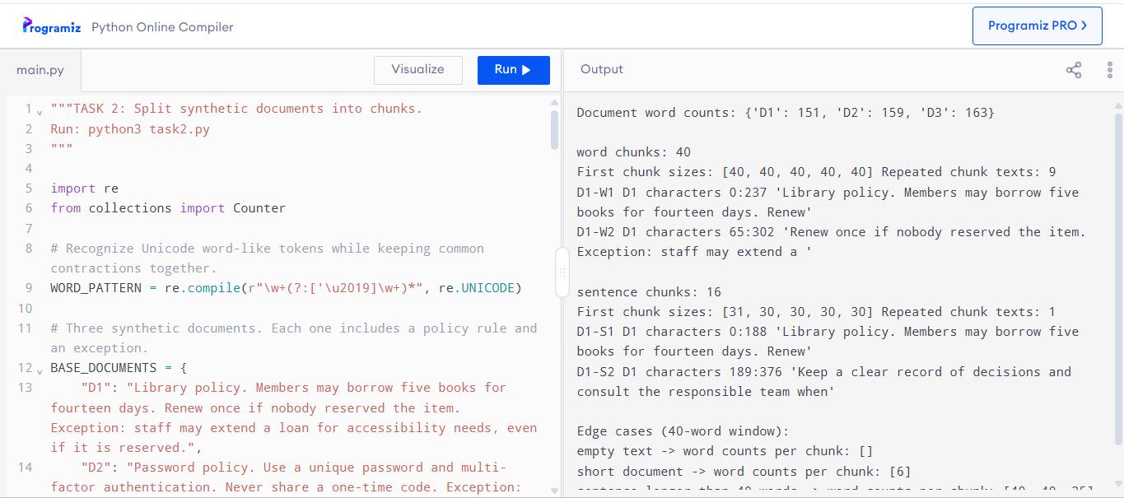
Question 3
Create task3_retrieval.py using Task 2’s corpus. • Expand it to at least five documents, with related but conflicting passages, and manually label eight answerable queries plus two unanswerable queries. • Use four answerable queries for development and four untouched queries for final testing. • Compare word windows with overlaps 0 and 10 against sentence-aware packing; run both TF-IDF and real sentence embeddings for all three strategies. • Audit model token lengths. • Print top-three text, scores, IDs and offsets; export a CSV log. Report Hit@3, MRR@3, chunk count, encoding/search time and at least three failures. • Measure model load separately. • Justify a strategy on development results and report it held-out results without retuning. • Explain why highest-score retrieval still returns text for an unanswerable query. • Any rejection threshold must be calibrated on separate development examples; no universal cosine cutoff is assumed. • Integrate the selected configuration into document_chatbot.py using the reference below. • Provide an interactive query loop, source offsets and a confirmation-based evidence display. • Keep unanswerable queries from receiving automatically asserted answers. • Compare FAQ matching with document retrieval and explain missing context and conflicting-source failures.
What I did

Overall idea
This program builds a small document search system (a retrieval chatbot) and tests how accurate it is. It does not generate answers. It only finds the most relevant piece of text for a question and measures how well that works.

Step 1: Create documents
Five short policy documents are created: library, password, travel, data retention, and support. Each has a rule and an exception. A padding sentence is added again and again until each document has at least 150 words.

Step 2: Split documents into chunks
Two methods are used:
- Word method: takes 40 words at a time and moves forward 10 words, so chunks overlap.
- Sentence method: groups whole sentences up to 40 words, and splits any sentence longer than 40 words.
Each chunk is saved with an ID, its source document, and its start and end character positions.

Step 3: Convert text into numbers (TF-IDF)
Every chunk is turned into a TF-IDF vector. TF means how often a word appears in the chunk. IDF means rare words get a higher weight than common words. The vectors are normalized so long chunks do not win automatically.

Step 4: Find the best chunk for a question
The question is also converted into a TF-IDF vector. It is compared with every chunk using cosine similarity. The chunk with the highest score is returned as the best match.

Step 5: Accept or refuse using a threshold
If the best score is at least the threshold, the result is accepted. If it is below the threshold, the question is refused. This is important for unanswerable questions like "solar panels" or "annual leave", which the documents do not cover.

Step 6: Choose the threshold fairly
There are two sets of questions:
- Development questions: used to choose the best threshold.
- Held-out questions: used only for final testing, never for tuning.
This keeps the test fair.

Step 7: Calculate metrics
For each question, the result is counted as:
- True positive: accepted and from the correct document.
- False positive: accepted but wrong, or accepted for an unanswerable question.
- False negative: refused although the question was answerable.
From these, precision, recall, and F1 score are calculated.

Step 8: Optional embeddings comparison
If the sentence-transformers package and the all-MiniLM-L6-v2 model are already installed on the computer, the program repeats the same test using embeddings instead of TF-IDF. If not, it prints a message and skips this part.

Step 9: Print the results
For both chunking methods, the program prints the number of chunks, the threshold, and the precision, recall, and F1 for development and held-out questions. At the end it prints notes: these numbers measure retrieval only, weak matches should be refused, FAQ matching suits a few fixed questions while document retrieval suits longer policies, and exceptions and the current approved source must always be checked.

Step 10: Interactive mode (optional)
If you run python3 task3.py --interactive, you can type your own questions. For each question, the program either says "No reliable match" or shows the possible source, chunk ID, character positions, and text. It then asks y/n. If you type y, it reminds you to use only the shown text and check its exception and version. If you type n, it asks you to rephrase or ask a human.

Code Screenshot
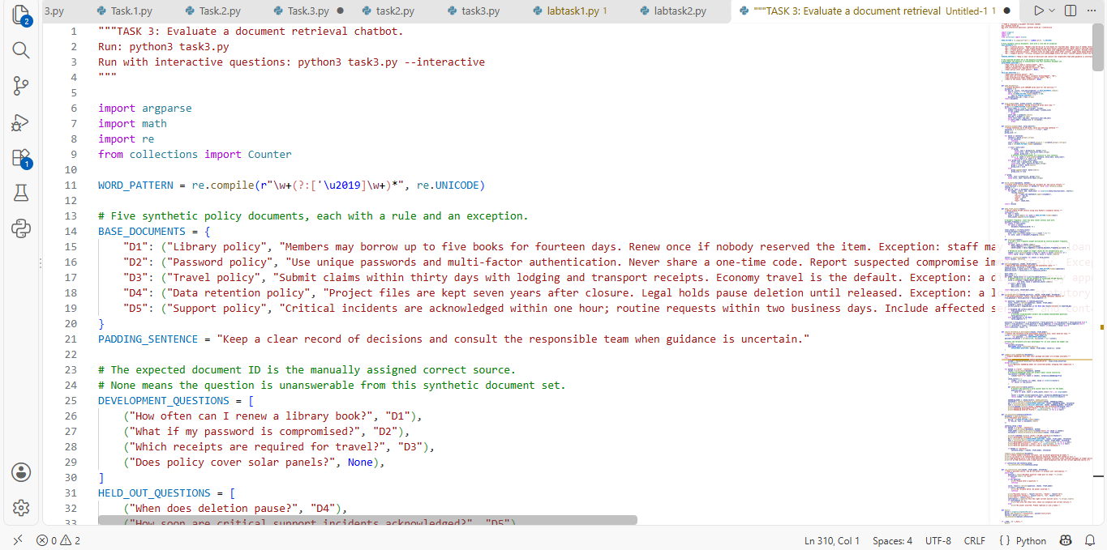
Code Explanation

PART 1: SETUP

WORD_PATTERN = re.compile(r"\w+(?:['\u2019]\w+)*")
Finds words. \w+ matches letters and digits. The second part keeps contractions together, so can't is one word.

BASE_DOCUMENTS
A dictionary: ID -> (title, text). Example: "D1" -> ("Library policy", "Members may borrow...").

DEVELOPMENT_QUESTIONS and HELD_OUT_QUESTIONS
Lists of (question, correct document ID). None means the answer is not in any document. Development questions are for tuning, held-out questions are for the final test.

PART 2: BUILDING THE DATA

make_documents()
text = title + ". " + rule_and_exception
while words < 150: add PADDING_SENTENCE
Result: 5 documents of 150+ words each.

word_windows(text, 40, 10)
- finditer gives every word with its position.
- range(0, len(words), stride) starts a window every 10 words.
- words[start:start+40] takes 40 words.
- start_char = first word start, end_char = last word end, so the chunk is cut from the original text.
- yield returns one chunk at a time (a generator).
- The break stops after the window that reaches the end of the document.

sentence_windows(text, 40)
- The regex [^.!?]+(?:[.!?]+|$) cuts text at . ! or ?.
- Case 1: sentence longer than 40 words. Save the current group, then split this sentence with word_windows (stride = window size, so no overlap).
- Case 2: adding the sentence would pass 40 words. Save the current group, start a new group with this sentence.
- Case 3: otherwise, add the sentence to the current group.
- After the loop, save the last group.

build_chunks(documents, method)
Runs the chosen method on every document and stores each chunk as a dictionary:
id (like D1-W1 or D1-S1), source (D1), start, end, text.

PART 3: TF-IDF (TURNING TEXT INTO NUMBERS)

make_tfidf_vectors(texts)
1. term_counts: for each chunk, a Counter of lowercase words.
2. document_frequency: in how many chunks each word appears.
3. IDF = log((N + 1) / (count + 1)) + 1. Rare word = bigger value. Common word = smaller value.
4. vectorize(counts):
- TF = 1 + log(count), so repeating a word many times does not grow the score too much.
- weight = TF x IDF.
- Divide every weight by the vector length (normalization), so all vectors have length 1.
5. Returns (all chunk vectors, the vectorize function).
Note: a question word that is not in any chunk gets weight 0 (idf.get(word, 0)), so it is ignored.

retrieve(question, chunks, tfidf_model)
- Converts the question into a vector with the same vectorize function.
- For each chunk: score = sum of (question weight x chunk weight) over shared words. Because both vectors are normalized, this is cosine similarity (0 to 1).
- Keeps the highest score and its chunk.
- Returns (best_score, best_chunk).

PART 4: EVALUATION

calculate_metrics(questions, chunks, model, threshold)
For each question:
- accepted = score >= threshold
- correct_source = the retrieved chunk's document equals the expected document
Counting:
- accepted and correct -> true positive
- accepted but wrong or unanswerable -> false positive
- not accepted but answerable -> false negative
- not accepted and unanswerable -> correct refusal (not counted anywhere)
Formulas:
precision = TP / (TP + FP) (how many accepted answers were right)
recall = TP / (TP + FN) (how many answerable questions were found)
F1 = 2 x precision x recall / (precision + recall)
The "if ... else 0" parts avoid division by zero.

choose_threshold_on_development(chunks, model)
- Gets the best score of every development question.
- Candidate thresholds = 0, (highest score + 1), and every development score.
- Picks the candidate with the best development F1. The key (F1, value) means that on equal F1, the higher threshold wins.
- Held-out questions are never used here.

Why the threshold matters:
Too low -> unanswerable questions (solar panels) are accepted, so false positives go up.
Too high -> real questions are refused, so false negatives go up.

PART 5: OPTIONAL EMBEDDINGS

compare_local_embeddings(documents)
- Tries to load SentenceTransformer("all-MiniLM-L6-v2", local_files_only=True). local_files_only means it will not download anything.
- If the package or model is missing, the except block prints a message and returns.
- If available, for both chunk methods it encodes chunks into dense vectors, builds the same (vectors, vectorize) pair that retrieve() expects, chooses the threshold on development questions, and prints dev and held-out precision, recall, and F1.
- embed_question rebuilds the question text from the word counter, so word order is lost. This is a small limitation.
- Because it uses the same retrieve() and calculate_metrics(), no other code needs to change.

PART 6: RUNNING EVERYTHING

run_evaluation(interactive)
1. Makes documents and prints their word counts.
2. For "word" and "sentence": builds chunks, builds TF-IDF, chooses the threshold, prints dev and held-out metrics.
3. Saves the sentence setup (chunks, model, threshold) for the chat.
4. Calls compare_local_embeddings.
5. Prints final notes about retrieval-only evaluation, refusing weak matches, FAQ vs document retrieval, and checking exceptions.
6. If interactive is on, starts the chat.

run_interactive_chat(chunks, model, threshold)
Loop: read question -> quit stops -> empty gives a message -> retrieve.
- Score below threshold: "No reliable match. No answer asserted."
- Otherwise it shows the source, chunk ID, offsets, and text, then asks y/n.
- y: use only the shown text and check its exception and version.
- n: no answer is given; rephrase or ask a human.

main()
Creates the --interactive flag with argparse and calls run_evaluation().

if __name__ == "__main__": main()
Runs the program only when the file is executed directly.

EXAMPLE FLOW
Question: "When does deletion pause?"
1. Lowercase words: when, does, deletion, pause.
2. Vectorize them with TF-IDF. Rare words like deletion and pause get high weight.
3. Compare with all chunks. The D4 chunk containing "Legal holds pause deletion" gets the highest score.
4. If the score is at or above the threshold, it is accepted and the source is D4, which matches the expected document, so it is a true positive.
Code Running Screeshot
